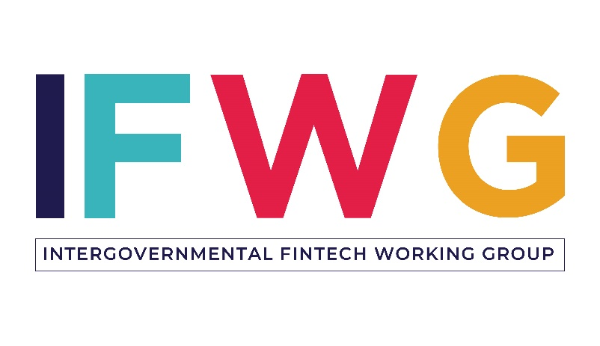

**REGULATORY SANDBOX APPLICATION**

***The Regulatory Sandbox is a controlled environment that offers regulatory relief for participants to test innovative products and services within predefined parameters. It is managed by the Intergovernmental Fintech Working Group (IFWG) with participation from the Financial Intelligence Centre, the Financial Sector Conduct Authority, National Treasury, the National Credit Regulator, the South African Reserve Bank, and the South African Revenue Service.***

*Please send your completed application form to* [*sandbox@ifwg.co.za*](mailto:sandbox@ifwg.co.za)*.*

***Applications will be assessed against the Regulatory Sandbox’s eligibility criteria:***

* The innovation to be tested must be intended for deployment in the South African market
* The innovation to be tested must not clearly fit within the existing regulatory framework or it challenges the existing regulatory framework
* The innovation must be beneficial to consumers or the market at-large (e.g., for business-to-consumer companies – lower prices, increased competition, improved access/financial inclusion; for business-to-business companies – lower costs, increased efficiency, improved regulatory compliance)
* The innovation is significantly different from other offerings in the market
* The innovation is ready to be tested, including fully developed technology, sufficient funding to cover the full testing period, and secured partnerships (if required for testing)
* The applicant must have a clear and detailed test plan, including:
  + Clear objectives and success criteria for testing
  + Timeline and milestones for testing
  + Identification of regulatory requirements and/or required regulatory relief
  + Possible risks (including risks to consumers) and risk mitigation strategies
  + An acceptable exit and transition strategy

*Upon reviewing your application, the Regulatory Sandbox team may reach out for additional information including financial statements, bank guarantees, affected party consent, proof of contractual arrangements with required partners, etc.*

*Submission of this application confirms that information supplied herewith is true and accurate to the best of the applicant’s knowledge.*

|  |  |
| --- | --- |
| Contact Information |  |
| Name of organisation |  |
| Address |  |
| Name of authorised organisational representative |  |
| Title of organisational representative |  |
| Contact number |  |
| Alternative contact number |  |
| Email |  |
| Business website URL |  |
| Organisational Profile | |
| Organisation registration number |  |
| Country of incorporation |  |
| Year of incorporation |  |
| CEO name |  |
| Names, titles and organisational affiliations of Directors of Board (if applicable) |  |
| Primary country of business operations |  |
| Primary financial sector activity of the organisation | * Payments * Lending * Savings & deposits * Insurance |
|  | * Investments * Financial planning & advisory services * Capital raising * B2B technology |
| Provide a brief description of your organisation’s core activities. |  |
| Provide information of the organisation’s authorised regulatory status (in South Africa or internationally). |  |
| Have you previously participated in a Regulatory Sandbox in a different jurisdiction? |  |
| Have you previously participated or are you currently participating in an incubator or accelerator programme? |  |
| How did you hear about the IFWG’s Regulatory Sandbox? If from the IFWG’s Regulatory Guidance Unit, please provide the reference number used in your interaction. |  |
| Have you previously communicated with any South African regulators concerning your proposition? If so, please provide a summary of the communications. |  |

|  |  |
| --- | --- |
| Proposition |  |
| Provide a description of the proposed financial product or service to be tested in the Sandbox, including:   * Type of innovation being tested * Current stage of development * What makes your proposition different from other products or services in the market   *(A business plan and/or pitch deck may be submitted with your application to provide additional information)* |  |
| Explain the expected benefits of the proposition to consumers or the broader market. |  |
| Provide a summary of the risks associated with the proposition and how you propose to mitigate those risks within the Sandbox testing environment. |  |
| Provide an assessment of the suitability of the proposed financial product or service for the South African market. |  |
| If applicable, please provide the names and contact information of any partners required to complete the proposed testing, as well as a description of their role in the proposed testing and existing or required contractual agreements. |  |
| Indicate how the proposition addresses the regulatory objectives or focus areas as listed on the Sandbox website or as confirmed through discussion with the relevant regulators (who may be approached, for instance, through the Regulatory Guidance Unit) |  |
| Required Regulatory Relief |  |
| Is your business currently regulated by any authorities? If so, please list the regulated activities, applicable regulatory authority and related legislation. |  |
| Does anything in the current regulatory framework prohibit operations of the proposition? If so, please elaborate. |  |
| Does the proposition require a regulatory authority to provide specific regulatory relief (e.g., exemption) for testing in the Sandbox?  If so, provide a description of the required regulatory relief, including:   * Citation of the legislation * Relevant regulatory authority |  |
| Have you previously sought legal advice on the proposition? If so, please provide a summary of the legal opinion received from a qualified legal practitioner. |  |

|  |  |
| --- | --- |
| Test Plan |  |
| What is being proposed for testing in the Sandbox? |  |
| What is the objective of the testing? |  |
| What is the proposed timeline and associated milestones for the 6-month Sandbox testing period? |  |
| What type of customers will participate in the test? How will these customers be identified and what is your plan to notify them of the nature of testing in the Sandbox? |  |
| How will you measure success of testing in the Sandbox? |  |
| In the event that the testing proves successful, please elaborate on the next steps. |  |
| In the event that the testing proves unsuccessful or the proposition proves unviable in the market, please elaborate on your proposed exit plan including notification of and, if required, compensation to customers. |  |